CHAPTER 4: Chemical patterns
Worksheet 4.3

Electron shells
Student: Class:

Electron configuration
1. Complete the following table.
Atom or ion | Proton number | Electron number | Electron configuration
Sodium atom (Na) | 11
Fluorine atom (F) |  | 9
Carbon atom (C) |  |  | 2, 4
Calcium atom (Ca) |  |  | 2, 8, 8, 2
Chloride ion (Cl–) |  |  | 2, 8, 8
Oxide ion (O^{2–}) | 8
Magnesium ion (Mg²⁺) | 12 |  | 2, 8
Aluminium ion (Al³⁺) | 13

Exciting the electrons
2. A student performed the experiment shown in the diagram below.
 | 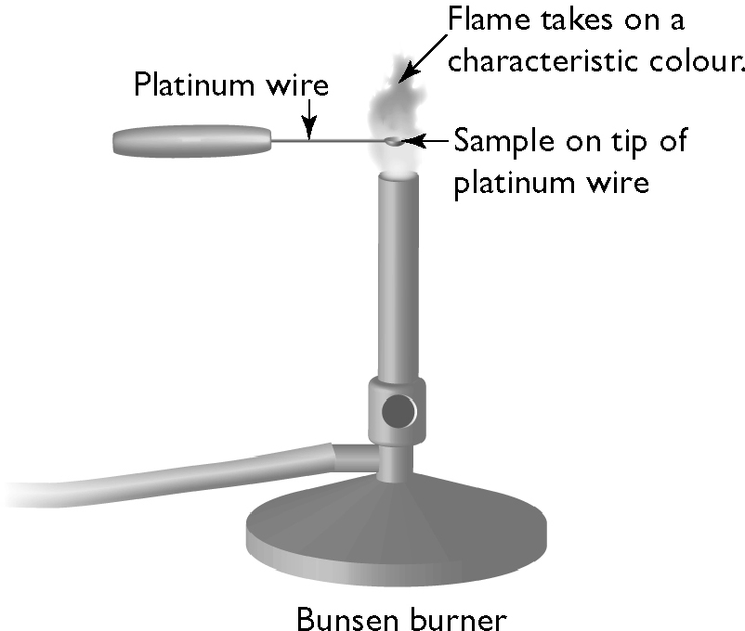 |  | A sample of salt (sodium chloride) is placed on the tip of a platinum wire. When the sample is heated in a blue Bunsen flame the flame turns yellow.  Use the theory of electron shells to explain this observation.

Electron shell population
3. Each electron shell is represented by a number (n) as shown in the following table.
Shell number (n) Maximum electron population  1  2  3  4 |  | The maximum electron number in each shell is given by the formula:  maximum electron number = 2n²  Complete the table by calculating the maximum electron population in each shell.

